Дата: 20.11.2023 Клас: 7-А

Предмет: Англійська мова

Тема: Рецепти з кулінарної книги.

Мета: формувати навички вживання нових лексичних; вдосконалювати навички читання й мовлення з опорою на лексико-граматичні структури; розвивати мовну здогадку й мовленнєву реакцію учнів; виховувати зацікавленість у розширенні своїх знань.

Вчитель: Глуговська Л.Г.

**Хід уроку**

***1.Greeting***Good afternoon, dear children! I’m glad to see you. Are you ready to start our lesson? Let’s start.

***2. Warming up/Speaking***

You may add more items.

*Example*: We use glasses for drinking water, cola, juice, milk, etc.

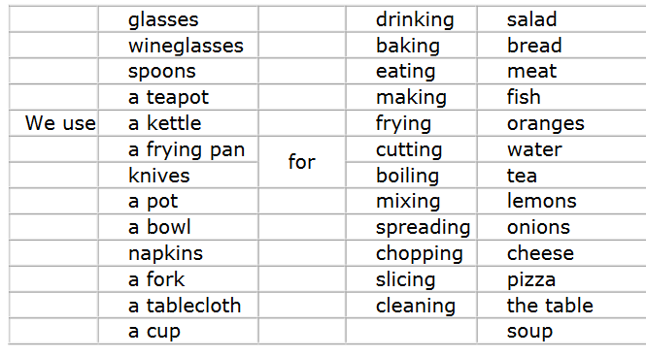

***3. Reading***

Read to the text and do the task.

NEWTON’S DINNER

One day a gentleman wanted to see Sir Isaac Newton just before dinner time.

Newton was busy and worked in his study. The visitor sat down in the dining room and waited for Newton. Soon the servant brought in Newton’s dinner. It was a chicken in a covered dish. An hour passed and Newton didn’t come. The gentleman began to feel hungry. He lifted the cover, saw the chicken and began to eat. Then he covered the dish and told the servant to boil another chicken. But before the second chicken was ready, Newton went in to have his dinner. Seeing the gentleman Newton said: “I beg your pardon, sir, but allow me to have my dinner first, as I’m hungry”. Then he lifted the cover, but finding the dish empty, he said: “Oh, I remember, I had my dinner already”.

***4. Checking read***

*Say if the following statements true or false.*

1. It was dinner time.

2. A young lady visited Newton before it.

3. Newton had already had his dinner before.

4. The servant had cooked chicken soup with vegetables.

5. The visitor was invited by Newton to share the dinner with him.

6. The servant was asked to boil one more chicken.

7. There was no chicken on the dish when Newton saw it.

***5.Grammar practice***

Do ex. 1, p. 74.

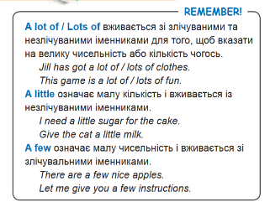

***6. Grammar practice***

***Exercise 1 page 74***

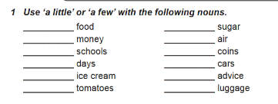

***7. Writing***

***Monday, the twentieth of November***

***Homework***

***Exercise 2 page 74***

***Доповніть речення, вживаючи «a little» / «a few».***

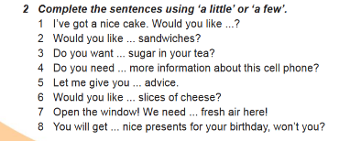

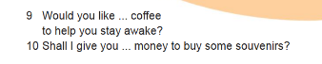

***8. Homework***

1. Опрацюйте конспект уроку;

2. Вивчити правило ст. 74

2. Exercise 2 page 74 (письмово).

**Надіслати виконане завдання у Вайбер/телеграм (0964124047) – Людмила Григорівна або на Human.**